Applying to Waterford Council for housing supports

To apply for Waterford, you must meet one of the following connections to the county

* Living in the area prior to applying
* Attending fulltime education in the area prior to applying
* Working in the area prior to applying

This must be proven to the council with supporting documents, see HAP checklist. If there are items missing, the form and all documentation will be sent back to you. When you have gathered the missing information, you must book another appointment.

Be sure you have access to the documents needed before booking your Housing needs assessment, otherwise your application will not be processed.

You will book your appointment online on

[Waterford City & County Council : Housing Applications Online Booking (waterfordcouncil.ie)](https://www.waterfordcouncil.ie/departments/housing/housing-app.htm)

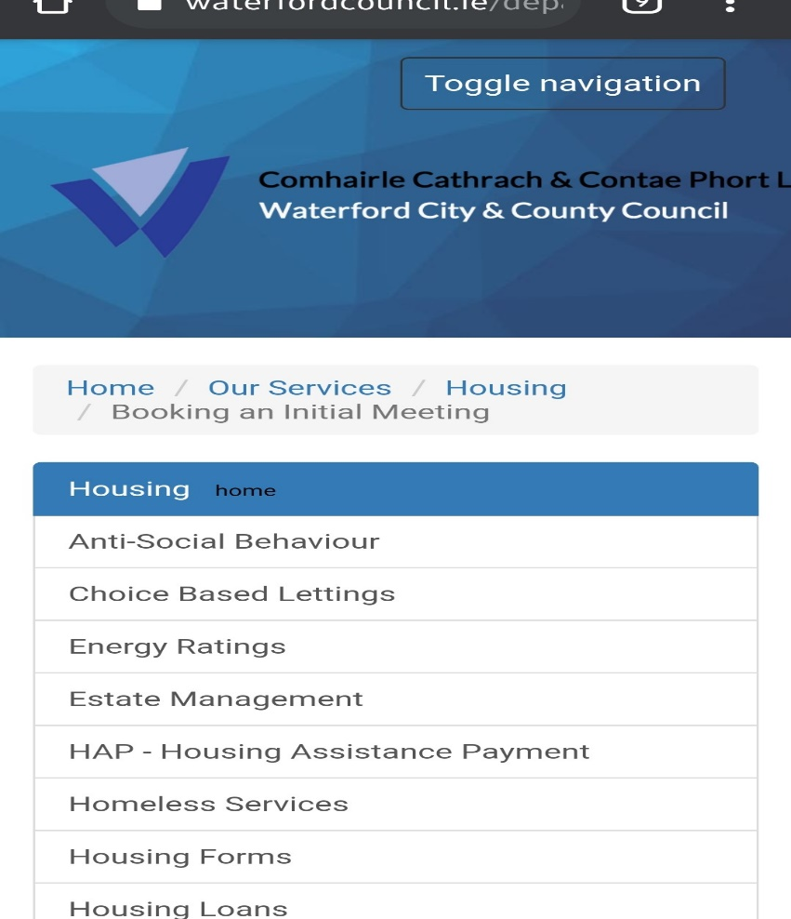

This is the page that will open when you click on the link.

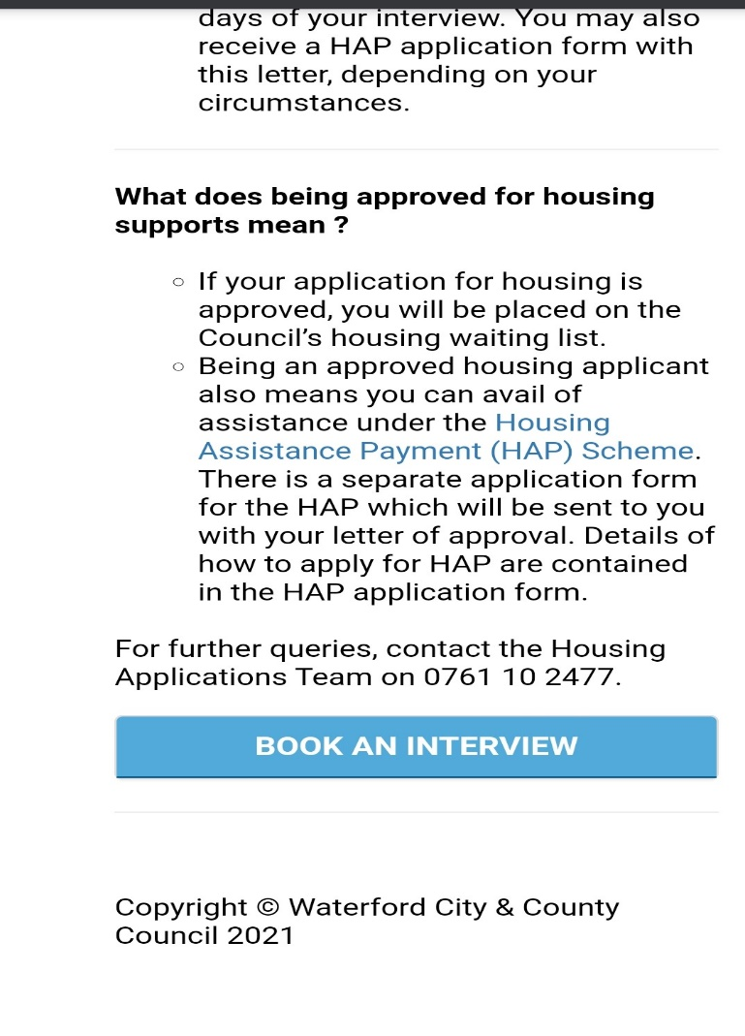Scroll down to the bottom of the page and click book and interview.

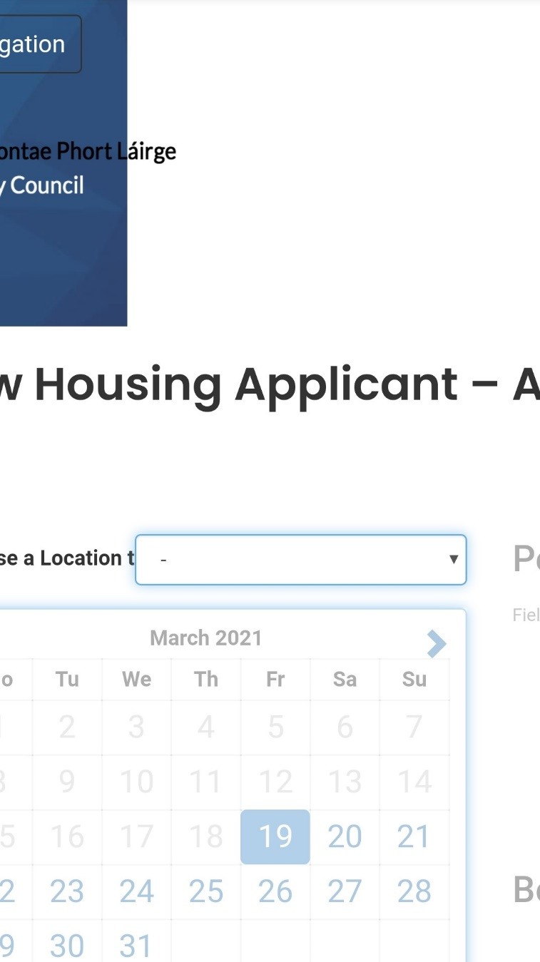

This page will open and you will click on the location tab.

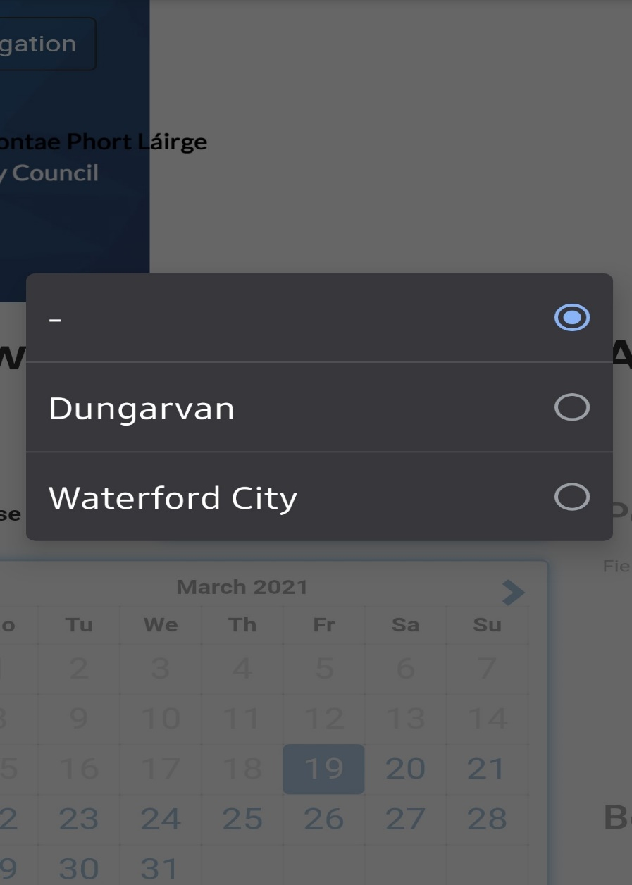Click on Waterford.

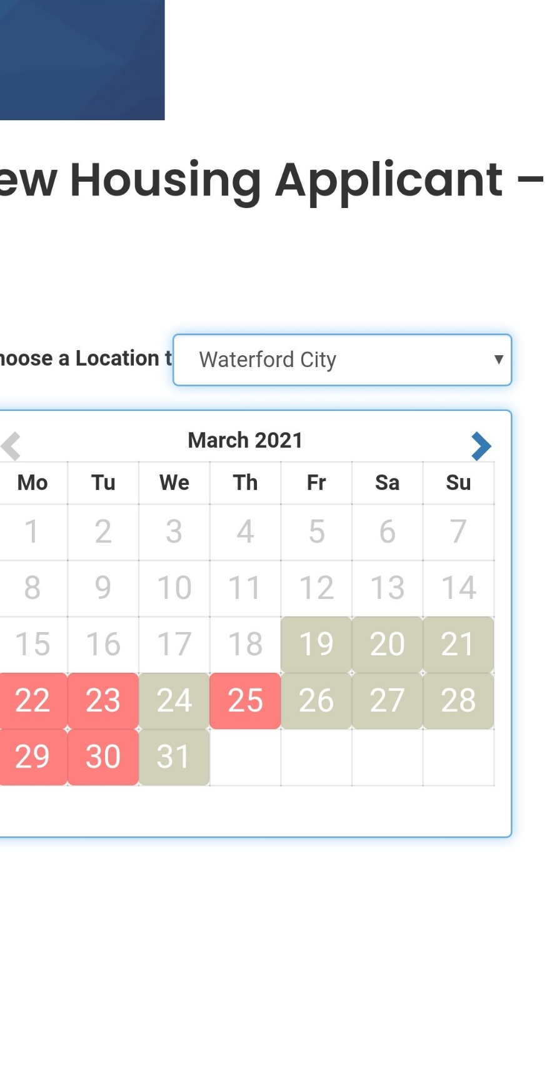

If the dates are blocked out like this, click the blue arrow to go to the next month.

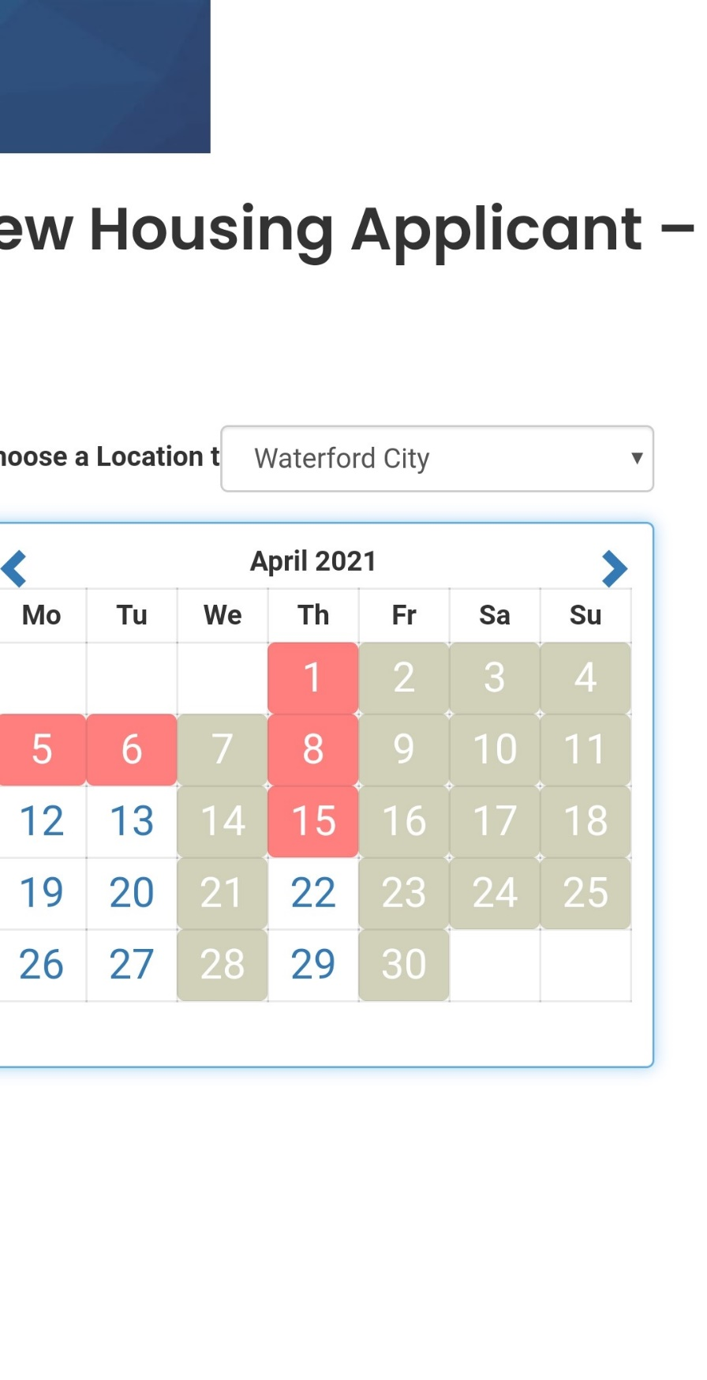

Click on a white date that suits you.

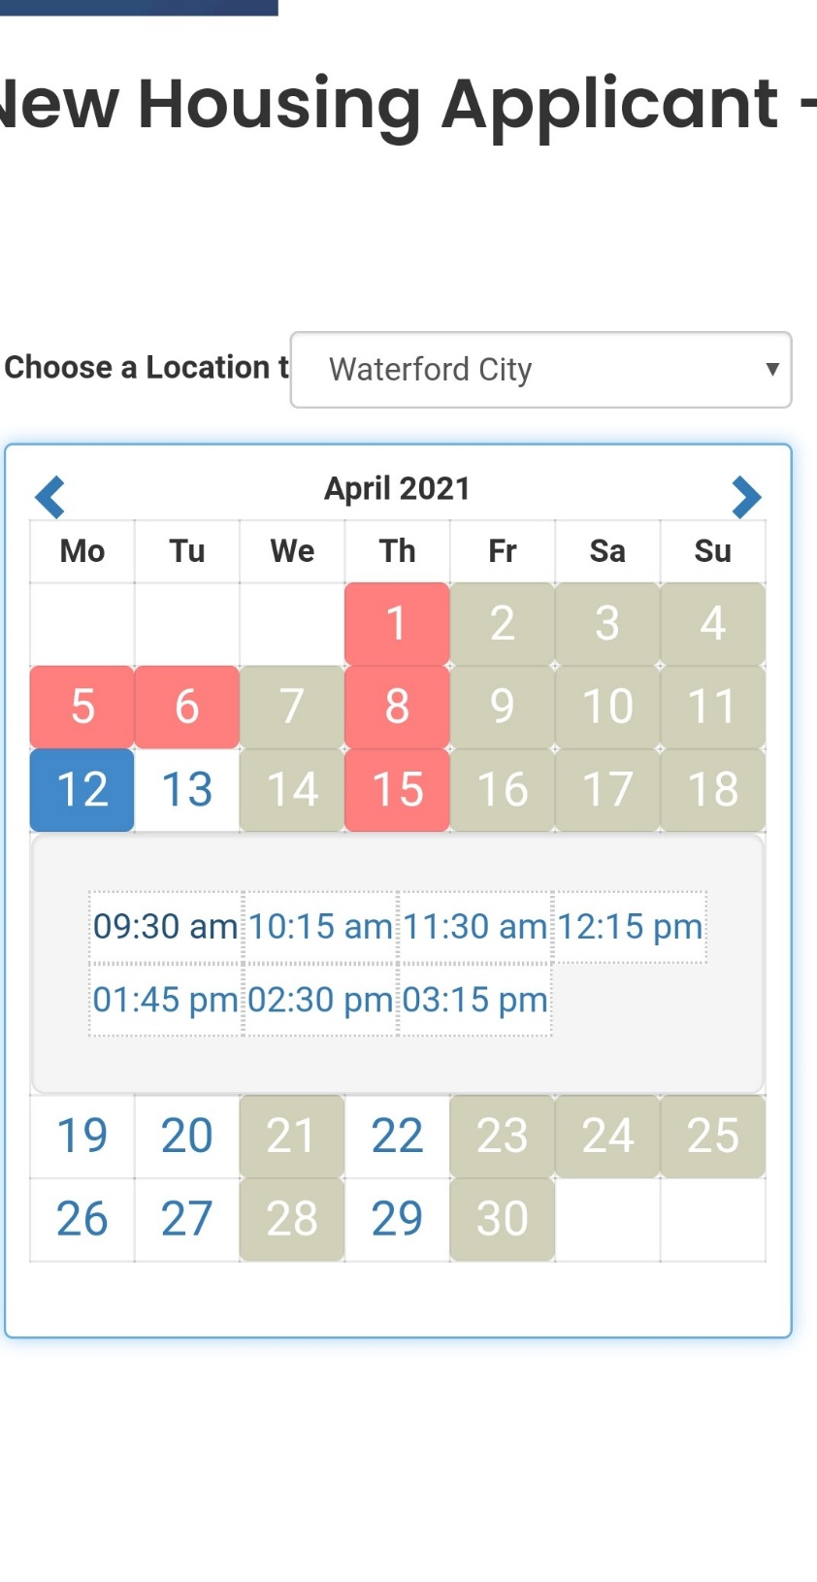

Click on a time that suits you.

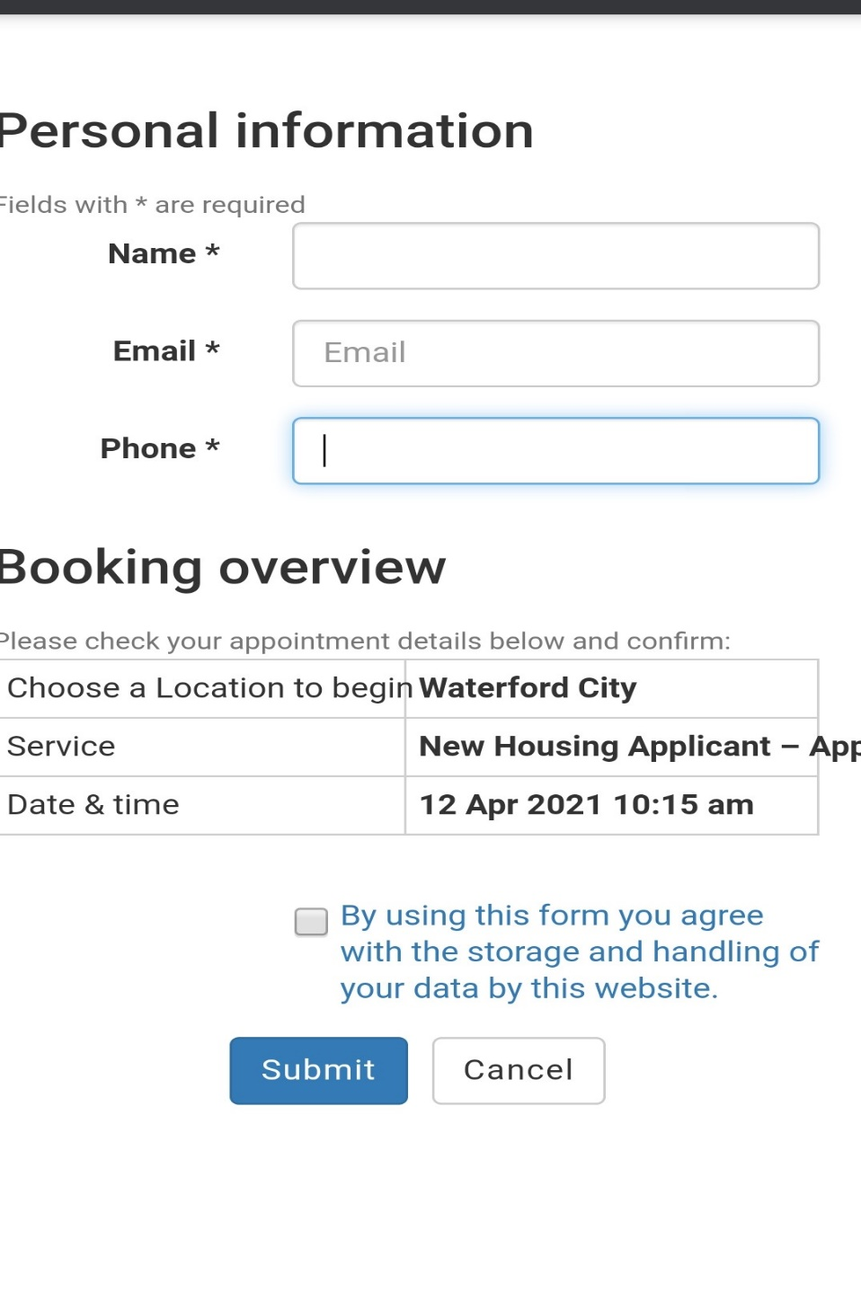Fill in your information and you will get an email confirmation.

You will get a call on the time and date you picked to go through your application.

Once this is done, you will need to gather all of the documents, fill in the application and post it to the council one week before your appointment. Post it to Housing Department, Bailey's New Street, Waterford. X91 XH42